18th ALBERT KANEPI TABLE TENNIS MEMORIAL
in Haapsalu, Estonia 9.-10. November 2024

DATE AND VENUE
18th Kanepi memorial will be held 9.-10. november 2024 at the Haapsalu Sport Center, Lihula mnt 10, Estonia.
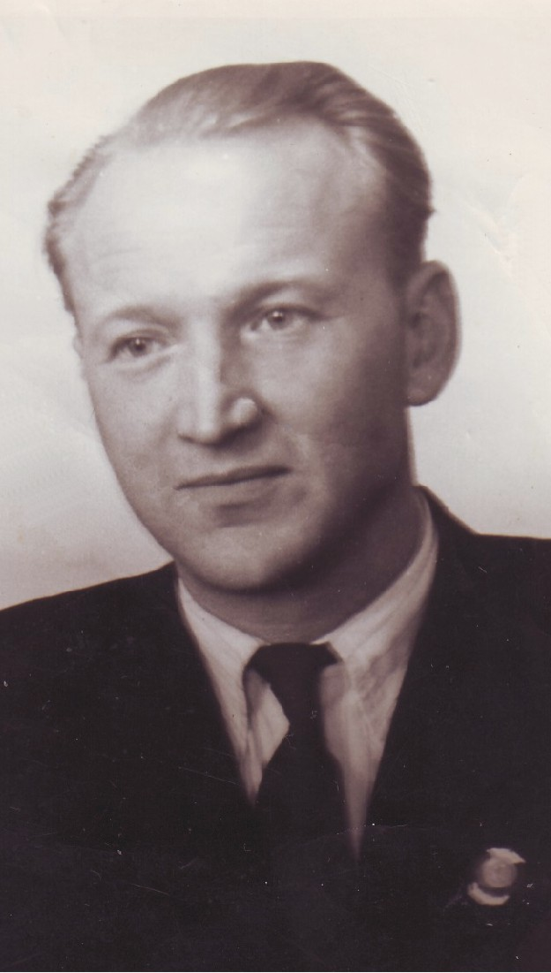
EVENT CATEGORIES, ENTRY FEE

Saturday 9/11/2024
Estonian children GP 3.stage
B/G U-9 2016 11:00 15.-€
B/G U-11 2014 15.-€
B/G U-13 2012 15.-€
B/G U-15 2010 15.-€
B/G U-17 2008 20.-€
A more detailed schedule will be announced after pre-registration.
All classes do not start at the same time.
Pre-registration must be done with the appropriate registration form.
Completed registration form should be sent here
aleksandr.kirpu@tammegymnaasium.ee
not later than 06.11.2024

Sunday 10/11/2024
Estonian GP 2.stage
M/W U-19 2006 10:00 20.-€
M/W 40+ 1985 10:00 20.-€
M/W 60+ 1965 10:00 20.-€
M/W SINGLES 13:00 20.-€
Pre-registration must be done here: https://forms.gle/D8TdnAZWzJNGPhMj7
Pre-registration ends on November 7.

SYSTEM OF PLAY
- All matches shall be determined by the best of five games only MS/WS FINALS best ot seven.
- ITTF and ETTU rules shall be applied as practically.

EQUIPMENT
Tables - 24 Donic Persson-25, blue;
balls *** DHS D40+ white plastic.

UMPIRES
Competition manager HEIKKI SOOL / IU
Referee ALEKSANDR KIRPU / IU (aleksandr.kirpu@tammegymnaasium.ee)
The Organiser will provide umpires for the semifinals and finals.

PRIZES
MS / WS Other categories
I 100.- € prizes,medals and diplomas
II 70.- €
III 40.- €

ENTRIES
Premilinary entries must be sent not later than 6st November 2024 to Heikki Sool E-mail: heikki.sool@gmail.com
Accreditation: Saturday 9/11/2024 9:00 - 0:30
Sunday 10/11/2024 9:00 - 9.30

HEIKKI SOOL
Competition Manager /IU
President of Haapsalu Table Tennis Club
+372 5205204
heikki.sool@gmail.com

WELCOME TO 18th ALBERT KANEPI MEMORIAL!

